Rathcormac NS
Drumcliffe, Co Sligo F91 NX21
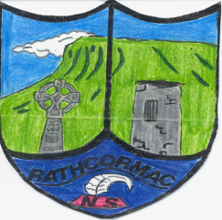
071-9143962 office@rathcormacns.ie

ANNUAL ADMISSION NOTICE
in respect of admissions to the 2026/27 school year.

Admission Policy and Application Form
A copy of the school’s Admission Policy and the Application Form for Admission for the 2026-2027 school year is available as follows: –
To download at: www.rathcormacns.ie
By emailing: office@rathcormacns.ie
Or writing to: Secretary, Rathcormac NS, Sligo. F91 NX21

Application and Decision Dates for admission to 2026/2027 school year

The school will commence accepting applications for admission on | 09/01/2026
The school shall cease accepting applications for admission on | 28/02/2026
The date by which applicants will be notified of the decision on their application is | 16/03/2026
The period within which applicants must confirm acceptance of an offer of admission is
7 days from date of offer

Failure to accept an offer within the prescribed period above may result in the offer being withdrawn

Note: the school will consider and issue decisions on late applications in accordance with the school’s admission policy.

Number of places being made available in 2026/2027 school year.

The number of places being made available in Junior Infants | 40
The number of places being made available in classes other than Junior Infants. | Dependant on the number of children already enrolled.

